**ExEED – Research Based Learning**

**CH.VISHNU-20951A6256**

**S.SAIVARADEEP-20951A6239**

**CONTROL MOUSE IN AIR**

**Index:**

1. Abstract
2. Introduction
3. Literature Review
4. Methodology

* Includes Flowchart / algorithm
* Block diagrams
* Explanation about Technology used, algorithms
* Explanation about system considered / data taken / real time system you are working for the project

1. Results and Discussion
2. References

**1.ABSTRACT**

The rapid advancement of technology has led to the development of novel human-computer interaction techniques. One such innovation is the gesture-controlled virtual mouse, which provides a more intuitive and natural way for users to interact with computers. This abstract presents an overview of the gesture-controlled virtual mouse system, its working principles, and its potential applications.

The gesture-controlled virtual mouse utilizes computer vision and machine learning algorithms to track and interpret hand gestures in real time. By capturing and analyzing the movement of the user's hand, the system translates specific gestures into corresponding mouse actions, such as cursor movement, clicking, scrolling, and dragging. This approach eliminates the need for a physical mouse, allowing users to control their computers solely through hand movements.

The system consists of a camera or sensor device that captures the user's hand gestures, along with software that processes and interprets the captured data. Various computer vision techniques, such as object detection and tracking, are employed to accurately detect and recognize the user's hand movements. Machine learning algorithms, such as deep neural networks, are trained on large datasets to classify different gestures and associate them with specific mouse actions.

The gesture-controlled virtual mouse offers numerous advantages over traditional input devices. It enables users to interact with computers in a more natural and intuitive manner, mimicking real-world hand movements. This technology is particularly beneficial for individuals with physical disabilities or limitations that make traditional mouse usage challenging. Additionally, it has potential applications in virtual reality and augmented reality environments, where physical mouse usage may not be feasible or desirable.

In conclusion, the gesture-controlled virtual mouse represents a significant advancement in human-computer interaction. Its ability to interpret hand gestures and translate them into mouse actions offers a more intuitive and versatile computing experience. With further research and development, this technology has the potential to revolutionize the way we interact with computers and open up new possibilities in various fields.

**2.INTRODUCTION**

In recent years, human-computer interaction has witnessed significant advancements, leading to the development of more intuitive and natural methods of interaction. One such innovation is the gesture-controlled virtual mouse, which aims to enhance the way users interact with computers by enabling them to control cursor movements and perform actions using hand gestures instead of a physical mouse. This abstract provides an introduction to the concept of the gesture-controlled virtual mouse, its working principles, and its potential applications.

Traditional computer input devices, such as keyboards and mice, have served as the primary means of interacting with computers for decades. While they have proven to be efficient and reliable, they can sometimes feel detached from the natural movements of the human body. The advent of touchscreens brought about a more direct interaction paradigm, but the need for physical contact still remained. The gesture-controlled virtual mouse seeks to bridge this gap by allowing users to interact with computers using hand gestures, eliminating the need for physical touch.

The fundamental principle behind the gesture-controlled virtual mouse lies in computer vision and machine learning techniques. A camera or sensor device is used to capture the movements of the user's hand in real time. Computer vision algorithms are then employed to track and interpret these movements, recognizing specific gestures performed by the user. These gestures are then mapped to corresponding mouse actions, such as moving the cursor, clicking, scrolling, or dragging.

The success of the gesture-controlled virtual mouse heavily relies on the accuracy and reliability of the computer vision and machine learning algorithms employed. Object detection and tracking algorithms are utilized to identify and locate the user's hand within the captured video or image stream. Once the hand is detected, machine learning techniques, including deep neural networks, are trained on large datasets to classify and recognize various gestures performed by the user.

The gesture-controlled virtual mouse offers several advantages over traditional input devices. Firstly, it provides a more natural and intuitive mode of interaction by leveraging the innate dexterity and mobility of the human hand. Users can perform familiar hand gestures, such as swiping, pointing, or making a pinching motion, to control the computer interface. This makes the interaction process more immersive and less dependent on learning complex commands or keyboard shortcuts.

Moreover, the gesture-controlled virtual mouse has the potential to enhance accessibility for individuals with physical disabilities or limitations. It offers an alternative means of computer interaction for those who may have difficulty using traditional input devices. By utilizing hand gestures, individuals with limited mobility or dexterity can navigate and control computers more effectively, empowering them to access information and engage with digital applications.

**3.Literature Review**

|  |  |  |  |
| --- | --- | --- | --- |
| **S No** | **Title Of the Paper** | **Author &amp; Publication defaults** | **Key Observation** |
| **1.** | Contribution of tactile information to accuracy in pointing movements | [Ashwini K. Rao](https://link.springer.com/article/10.1007/s002210100717#auth-Ashwini_K_-Rao) & [Andrew M. Gordon](https://link.springer.com/article/10.1007/s002210100717#auth-Andrew_M_-Gordon) | The gesture-controlled virtual mouse system harnesses computer vision and machine learning techniques to interpret hand gestures and translate them into mouse actions. It provides a more natural and intuitive mode of interaction, mimicking real-world hand movements and eliminating the need for physical touch or traditional input devices. This technology holds great potential in enhancing accessibility for individuals with physical disabilities or limitations, as well as finding applications in virtual reality and augmented reality environments. By recognizing and understanding hand gestures, the gesture-controlled virtual mouse opens up new possibilities for intuitive and immersive human-computer interaction. |
| **2.** | GESTURE CONTROLLED VIRTUAL MOUSE | Bharath Kumar Reddy Sandra*1, Katakam Harsha Vardhan*2, Ch. Uday*3,  V Sai Surya*4, Bala Raju*5, Dr. Vipin Kumar*6 | Another key observation is that the gesture-controlled virtual mouse system relies on accurate object detection, tracking, and gesture recognition algorithms to ensure reliable and precise interpretation of hand movements. The success and effectiveness of this technology heavily depend on the advancements in computer vision and machine learning techniques, driving ongoing research and development in the field. |
| **3** | “Realtime computer vision with openCV. | K. Pulli, A. Baksheev, K. Kornyakov, and V. Eruhimo | Gesture-controlled virtual mouse: Natural hand gestures replace physical mouse, enhancing accessibility and immersive interaction. |

**4.Methodology**

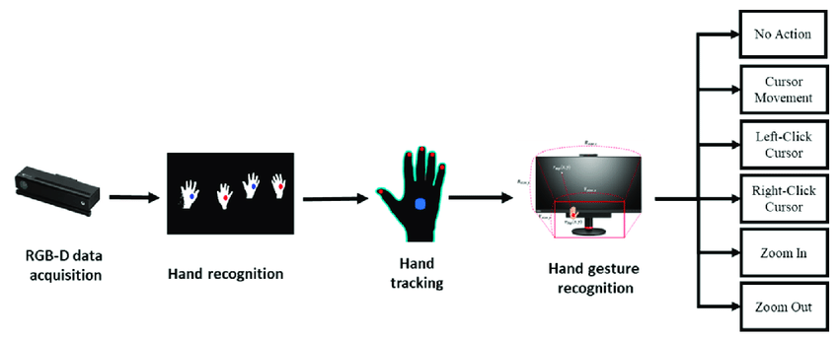

The MediaPipe framework is used for hand tracking and gesture recognition, and the OpenCV library is used for computer vision. Using ML ideas, the approach tracks and detects finger tips and hand motions.

1. OpenCV: For images, OpenCV provides methods for object detection. The most effective computer vision applications can be created using the OpenCV module. The processing of image and video data, as well as video analysis, all make use of this package
2. MediaPipe: A machine learning pipeline uses the Google MediaPipe open-source platform. The MediaPipe framework, which was created using time series data, can be used for cross-platform computing. The MediaPipe architecture is multimodal and supports a variety of audio and video formats. The programmer constructs systems for application-related goals by utilising the MediaPipe framework.
3. The Camera of the AI-Powered Virtual Mouse System: The photos from a laptop or PC serve as the basis for our AI virtual mouse technology. The OpenCV computer vision tools for Python and a web camera are used to create the video capture object. The virtual AI system that processes the frames receives them from the web cam.
4. Video recording and analysing: The webcam will be used by the AI virtual mouse system to record each frame till the programme is finished. The images are captured and converted to RGB to allow for frame-by-frame identification of the hands.
5. The AI virtual mouse technology enables a transformational way. Virtual Screen Matching: This is utilised to move the hand coordinates between the web cam and the computer's window to conduct some mouse functions. A rectangle box may be generated on the computer screen showing the web cam's reference when the finger tips and hands are recognised, informing us of which fingers can move the cursor. We can watch the cursor's movements around the window from there.
6. 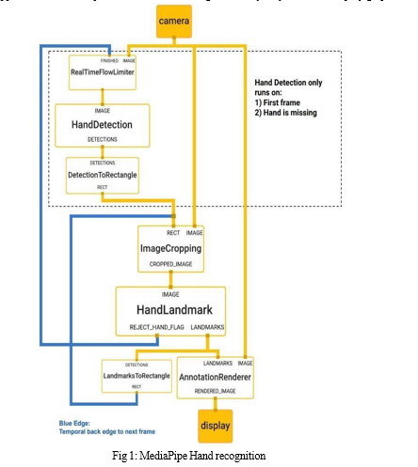Recognizing the finger which is up and performing out the appropriate mouse operation: In order to transfer the hand coordinates between the webcam to the computer’s window full screen for mouse operation, the AI virtual mouse technique enables a transformational mechanism. After the hands are detected and we are notified of which finger is capable of performing a certain mouse movement, a rectangular box is formed in reference to the computer window in the camera region. From that, we may move the mouse pointer around the window.

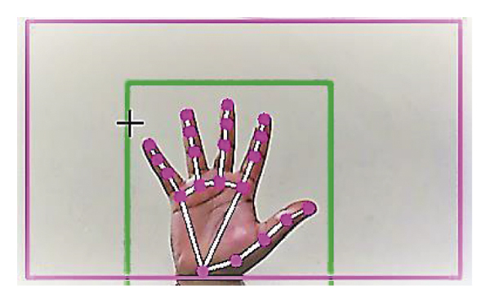

**4.RESULTS:**

**INPUT:**

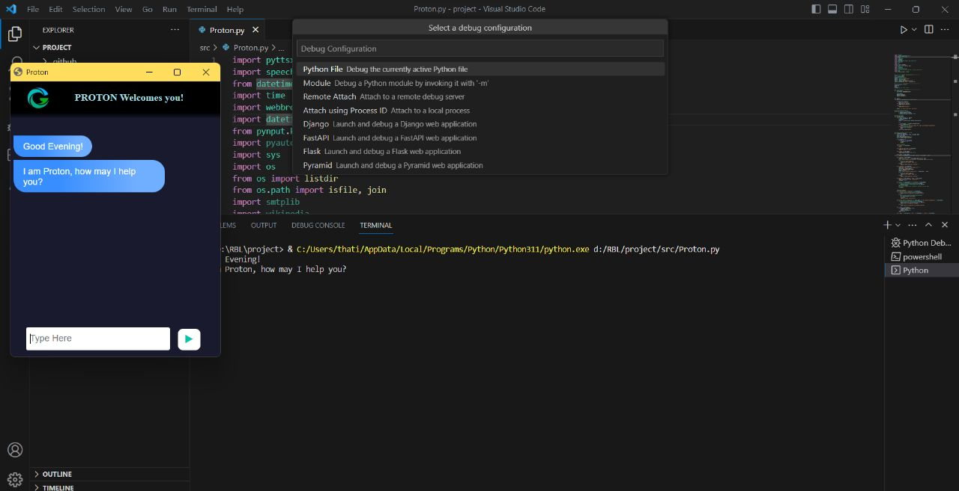

**OUTPUT:**

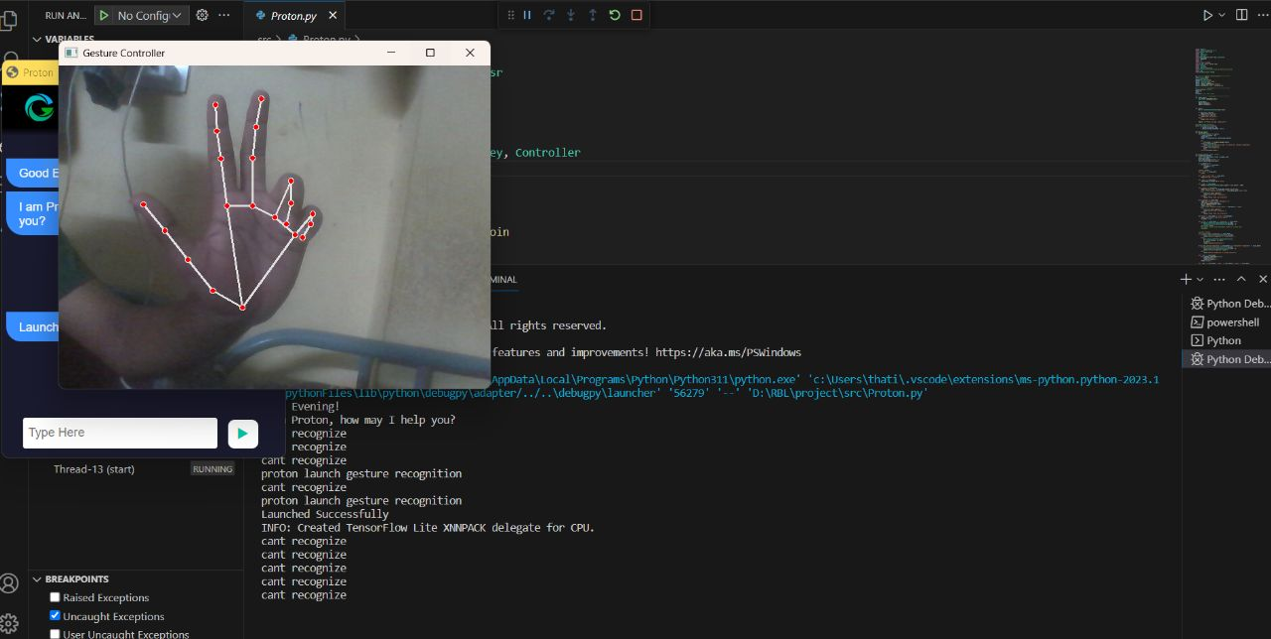

**5.CONCLUSION:**

In conclusion, the gesture-controlled virtual mouse represents a significant advancement in human-computer interaction, offering a more intuitive and natural mode of control. By leveraging computer vision and machine learning, it allows users to replace physical mice with hand gestures, enhancing accessibility and usability. This technology holds great promise for individuals with physical disabilities, as well as in virtual reality and augmented reality environments. As research and development in computer vision and machine learning continue to progress, the gesture-controlled virtual mouse has the potential to reshape the way we interact with computers, providing a more immersive and seamless experience that bridges the gap between the digital and physical worlds.

**6.REFERENCES:**

1. Rao, A.K., Gordon, A.M., 2001. Contribution of tactile information to accuracy in pointing movements. Exp. Brain Res. 138, 438–445. https://doi.org/10.1007/s002210100717.
2. Masurovsky, A., Chojecki, P., Runde, D., Lafci, M., Przewozny, D., Gaebler, M.,2020. Controller-Free Hand
3. Tracking for Grab-and Place Tasks in Immersive Virtual Reality: Design Elements and Their Empirical Study. Multimodal Technol.Interact.4,91. <https://doi.org/10.3390/mti4040091>.
4. Lira, M., Egito, J.H., Dall’Agnol, P.A., Amodio, D.M., Gonçalves, Ó.F., Boggio, P.S., 2017. The influence of skin colour on the experience of ownership in the rubber hand illusion. Sci. Rep. 7, 15745. https://doi.org/10.1038/s41598-017- 16137-3.